FYP Required Books Nursing (Semester 1)
Course Code | Course Title | Required Book
ENG101 | Basic English Reading (1) | 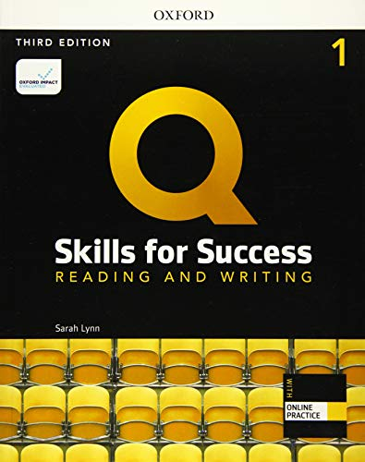
ENG102 | Basic English Listening & Speaking (1)
ENG103 | Basic English Writing (1)
ENG104 | Basic English Grammar (1) | 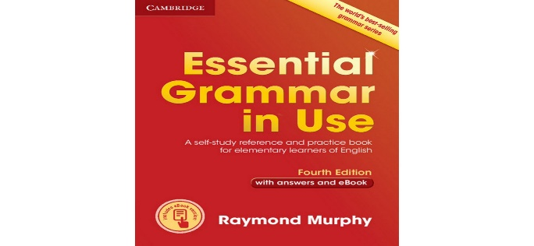
STS101 | Study Skills | Provided in Class
ME201 | Medical Terminology | Provided in Class
BCHEM101 | Basic Biochemistry | Provided in Class
COM102 | Information Communication Technologies | Provided in Class

