FYP Required Books MLS (Semester 1)
Course Code | Course Title | Required Book
ENG101 | Basic English Reading (1) | 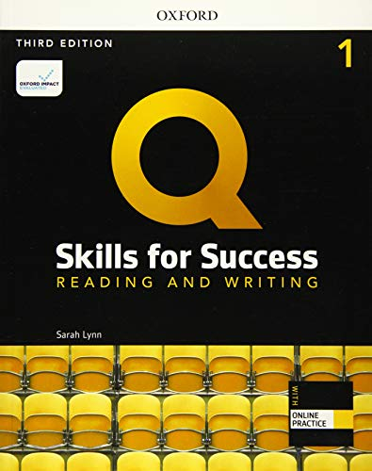
ENG102 | Basic English Listening & Speaking (1) | 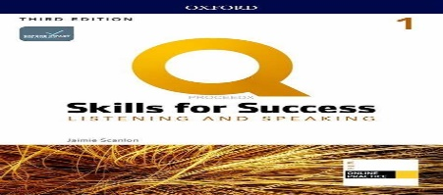
ENG103 | Basic English Writing (1)
ENG104 | Basic English Grammar (1) | 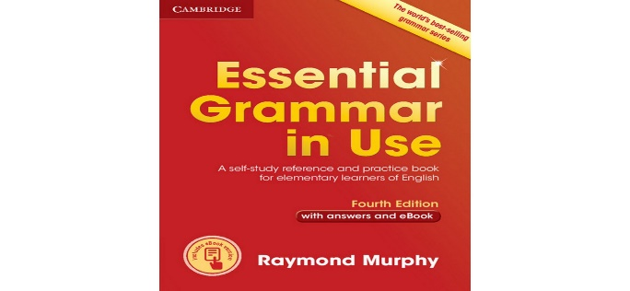
STS101 | Study Skills | Provided in Class
ME101 | Medical Terminology | Provided in Class
CHEM201 | Biochemistry | Provided in Class
COM102 | Information Communication Technologies | Provided in Class

