FYP Required Books Nursing (Semester 2)
Course Code | Course Title | Required Book
ENG111 | Basic English Reading (2) | 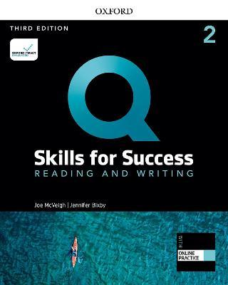
ENG112 | Basic English Listening & Speaking (2) | 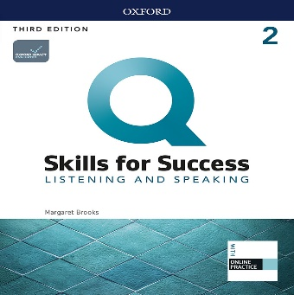
ENG113 | Basic English Writing (2)
ENG114 | Basic English Grammar (2) | 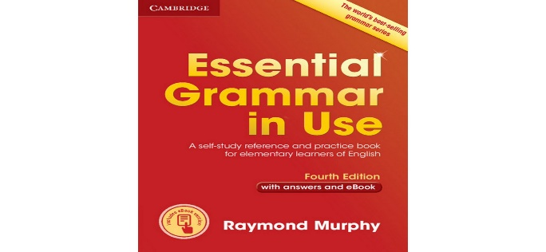
BBIOL201 | Basic Human Biology | Provided in Class
STAT101 | Biostatistics | Provided in Class
COS201 | Communication Skills | Provided in Class
PHYS106 | Medical Physics | Provided in Class

