FYP Required Books MLS (Semester 2)
Course Code | Course Title | Required Book
ENG111 | Basic English Reading (2) | 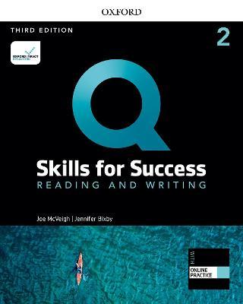
ENG112 | Basic English Listening & Speaking (2) | 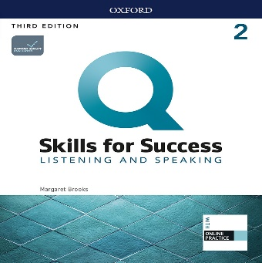
ENG113 | Basic English Writing (2)
ENG114 | Basic English Grammar (2) | 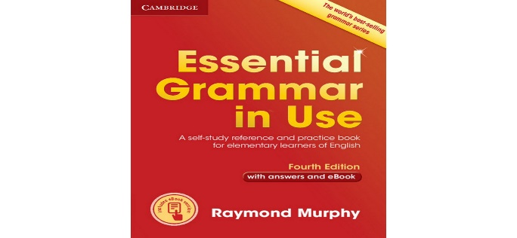
BIOL101 | Human Biology | Provided in Class
STAT101 | Biostatistics | Provided in Class
COS101 | Communication Skills | Provided in Class
PHYS106 | Medical physics | Provided in Class

